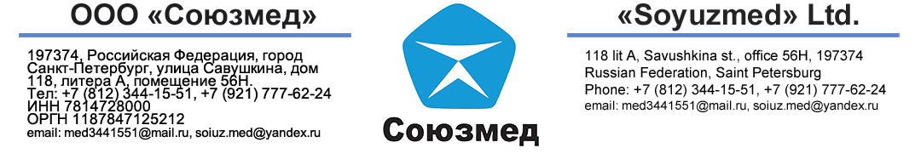
DRUG/ALCOHOL TEST REPORT № 96
Position applied for |  |  |  |  |  | Refmachinist |  |  |  |  |  | I certify that I am the same person  being tested for presence of drug and alcohol in my blood/urine whose name  ears on this medical record and that.  I have truthfully answered the questions asked regarding my well-being  ____________________  (Signature)
Name |  | IAKUNIN ALEKSEI
Address |  |  | c.Novorossiysk vill. Borisovka., str. Private Kapustov. 14. |  |  |  |  |  | Reg.Krasnodar  Russia
Age | 49 |  |  | Civil Status
 |  |  |  |  | Weight |  | 115 |  |  | kg
 |  |  |  |  | Height |  | 182 |  |  | cm
 |  |  |  |  | Hair color |  |  | Blond
(foto) |  |  |  |  | Eye color |  |  | Gray-blue
 |  |  |  |  | Distinguishing Mark: NIL
 |  |  |  |  | Date of test |  |  | 2025, October, 20
CERTIFICATION
I certify that laboratory examination of the blood/urine of applicant uses the text on the principle:
AGGLUTINATION IMMUNOASSAY
Did not detect presence of prohibited drugs:
DRUG | ACCEPTABLE LIMIT
OPIATES:
- Codeine | < 300 NG/ML | NIL | YES | NIL
- Morphine | < 300 NG/ML | NIL
- Heroine | < 10 NG/ML | NIL
Cannabis | < 50 NG/ML | NIL | YES | NIL
Cocaine | < 150 NG/ML | NIL | YES | NIL
Phencyclidine | < 25 NG/ML | NIL
Amphetamines | < 300 NG/ML | NIL | YES | NIL
Benzodiazepines | < 300 NG/ML | NIL
Methetadone | < 300 NG/ML | NIL
Propoxyphene | < 300 NG/ML | NIL
Barbiturates | < 300 NG/ML | NIL | YES | NIL
MDMA (ecstasy) | < 300 NG/ML | NIL
Methaqualone | < 300 NG/ML | NIL
Alcohol | < 40 MG/DL | NIL

Examination for significant alcohol level using chromatography method:
Did not detect presence of alcohol
Detected presence of alcohol
OTHER IMPRESSIONS:
NIL
__________________________ _______________
Medical technician Pathologist
The certificate is issued in accordance with ILO Seafarer’s Convention on Medical Examinations № 73.ILO MLC 2006, ILO/WHO/A2/1997, ILO Convention 147, STCW 95 Manila 2010 Amendments. Our clinic meet the requirements according to STCW.
The seafarer concern does not suffer from any medical condition likely to be aggravated by at sea or to render the seafarer unfit for such service or endanger the health of other person on board.

